QUICK SORT
Quick sort(pivot = first value)
AIM: To implement a python program for quick where the pivot value is the first value
ALGORITHM:
- Choose the first element as the pivot.
- Divide the array into two parts:
- Elements ≤ pivot
- Elements > pivot
- Recursively apply Quick Sort on the left part.
- Recursively apply Quick Sort on the right part.
- Combine the sorted left part + pivot + sorted right part to get the final sorted list.

PROGRAM:
def quick_sort(arr):
if len(arr) <= 1:
return arr
pivot = arr[0]
left = [x for x in arr[1:] if x <= pivot]
right = [x for x in arr[1:] if x > pivot]
return quick_sort(left) + [pivot] + quick_sort(right)
arr = [10, 7, 8, 9, 1, 5]
print("Sorted array:", quick_sort(arr))

OUTPUT:
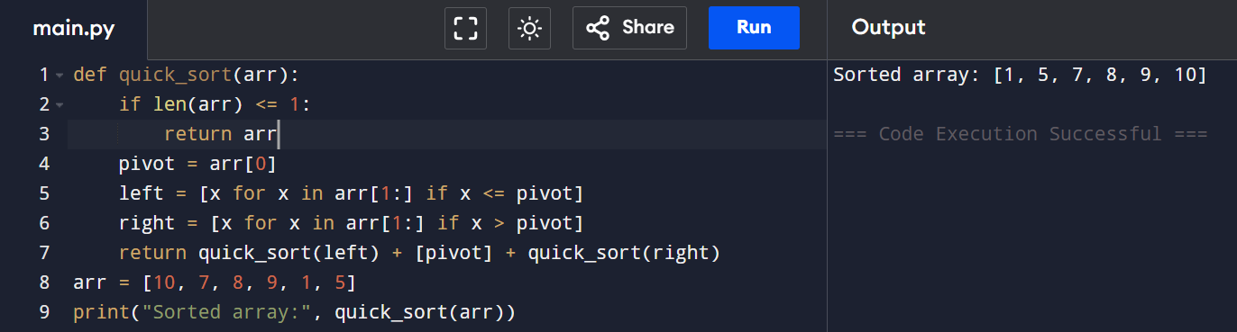
RESULT: The list is successfully sorted in ascending order using Quick Sort by choosing the first element as the pivot.
Quick sort(pivot = middle value)
AIM:
To implement the Quick Sort algorithm in Python using the middle element as the pivot for efficient sorting of a given list of numbers.
ALGORITHM:
- Choose the middle element of the array as the pivot.
- Partition the array into elements less than, equal to, and greater than the pivot.
- Recursively apply Quick Sort to the left and right subarrays.
- Combine the sorted left part, pivot group, and sorted right part to get the final sorted list.
PROGRAM:
def quick_sort(arr):
if len(arr) <= 1:
return arr
pivot = arr[len(arr) // 2]
left = [x for x in arr if x < pivot]
mid = [x for x in arr if x == pivot]
right = [x for x in arr if x > pivot]
return quick_sort(left) + mid + quick_sort(right)
data = [10, 7, 8, 9, 1, 5, 3]
print(quick_sort(data))
OUTPUT: 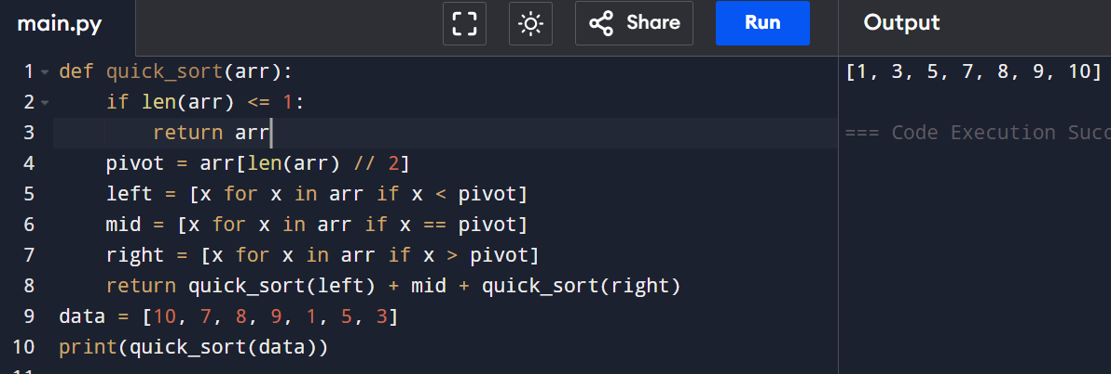

RESULT: The list is successfully sorted in ascending order using Quick Sort with a middle pivot.

